

**SAP Technical Specification**

|  |  |
| --- | --- |
| Project | **VIVO** |
| Customer | **Serco** |
| Solution | **Technical Specification** |
| Version | **0.1** |
| Author | **Naresh Palagiri** |
| Date  RLSE NO | **06.01.2022**  **RLSE0015275** |

WRICEF ID **FF0041_ECC**

Template Control

| Version | Date | Author | Notes |
| --- | --- | --- | --- |
| 0.1 | 13th August 2013 | Malcolm Smith | Created from existing templates |
| 1.0 | 4th Sept 2013 | John Brinkworth | First Issue |

Document Control

| Version | Date | Author | Notes |
| --- | --- | --- | --- |
| 0.1 | 06.01.2022 | Naresh Palagiri | Initial TS |
|  |  |  |  |

Document Location

| Location |
| --- |
| To be uploaded on Ourworld – TBD (Update the link once documents is signed off and uploaded) |

Approval

| Name | Role | Date | Signature |
| --- | --- | --- | --- |
| Dhiraj Jain |  |  |  |

Distribution

| Name | Role |
| --- | --- |
|  |  |

Table of Contents

1 Overview 4

2 General Information 4

3 Selection Screen 4

4 Database Tables / Structures Used 4

5 Program Details 4

5.1 Solution Details 4

6 Test Evidence 5

7 Annex A – Product Description (reference only) 6

Table of Figures

**No table of figures entries found.**

Table of Tables

**No table of figures entries found.**

# Overview

Under new company code **S601-VIVO** build, it is required to appear VIVO logo for given Payment methods. In current business process of Serco, below SAP script are in use.

# General Information

**SAP Script Names:**

Z110_IN_AVIS1

# Selection Screen

No selection screen

# Database Tables / Structures Used

No Tables

# Program Details

1. Go to SE78 and import new logo with name – VIVO_LOGO_S601

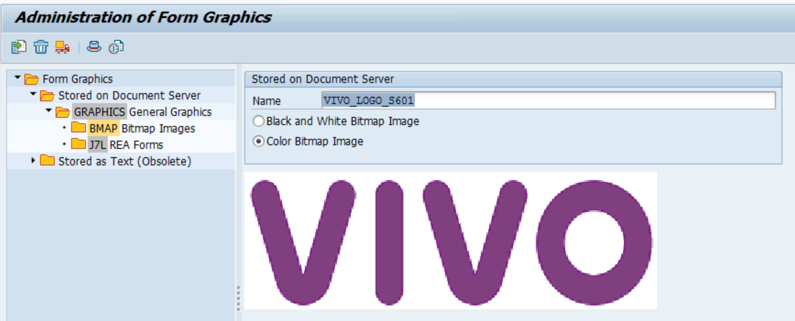

1. Go to SE71 and open SAP Script – Z110_IN_AVIS1
2. In Logo window, for company code S601 and payment methods VIVO logo is added.

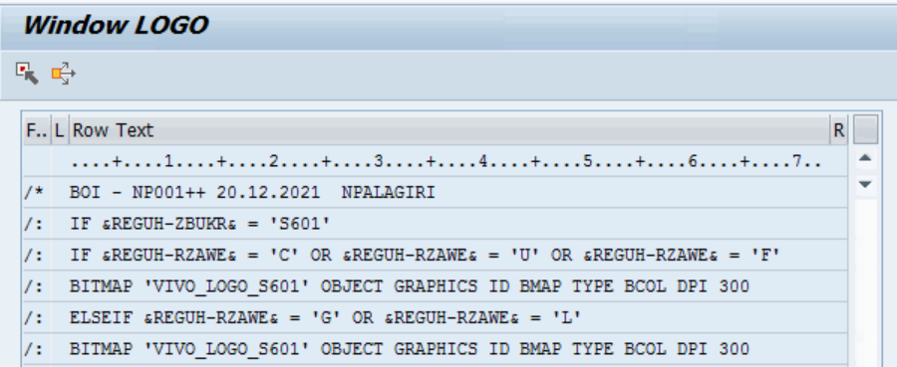

1. Existing logo placed in hidden for S601 non-payment methods.

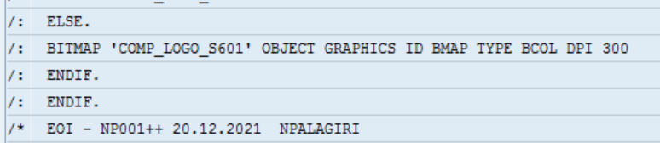

# Test Evidence



# Annex A – Product Description (reference only)

For reference purposes only – Delete if required

|  |  |
| --- | --- |
| **Product Description** | |
| **What?** | The SAP Technical Specification is a detailed description of the technical development required to meet the needs identified in the related Functional Specification. |
| **Why?** | The benefits of completing a SAP Technical Specification are:   * To provide a clear documentation of what has been developed in the system, and why. * To help future support and maintenance of the system. |
| **Who?** | The Developer is responsible for:   * Documenting the technical development requirements.   The Project Manager is responsible for:   * Ensuring that a Technical Specification document is completed for each development. |
| **When?** | The Technical Specification should be completed in the Design Stage:  Dependencies:  The Technical Specification should be delivered with the following considerations:   * Design of the Functional Specification. |
| **Hints and Tips** | N/A |
| **Next Steps** | Once completed you should consider the following products or actions:   * Testing |